**CONNECTING 3 VPC’s WITH TRANSIT GATEWAY**

**Transit Gateway**

A transit gateway is a network transit hub that you can use to interconnect your virtual private clouds (VPCs) and on-premises networks. As your cloud infrastructure expands globally, inter-Region peering connects transit gateways together using the AWS Global Infrastructure. All network traffic between AWS data centers is automatically encrypted at the physical layer.

* Creating the transit gateway btw 3 vpc in different regions

1. Vpc-central -10.21.0.0/16
2. Vpc – Virginia -10.31.0.0/16
3. Vpc – California -10.61.0.0/16

Created the three vpc in three different regions

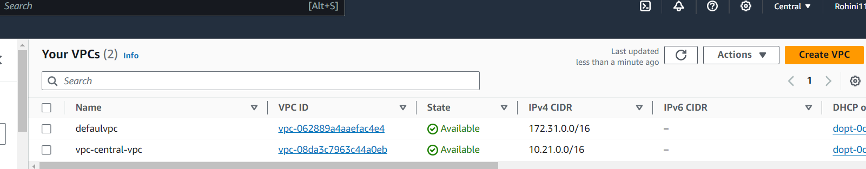

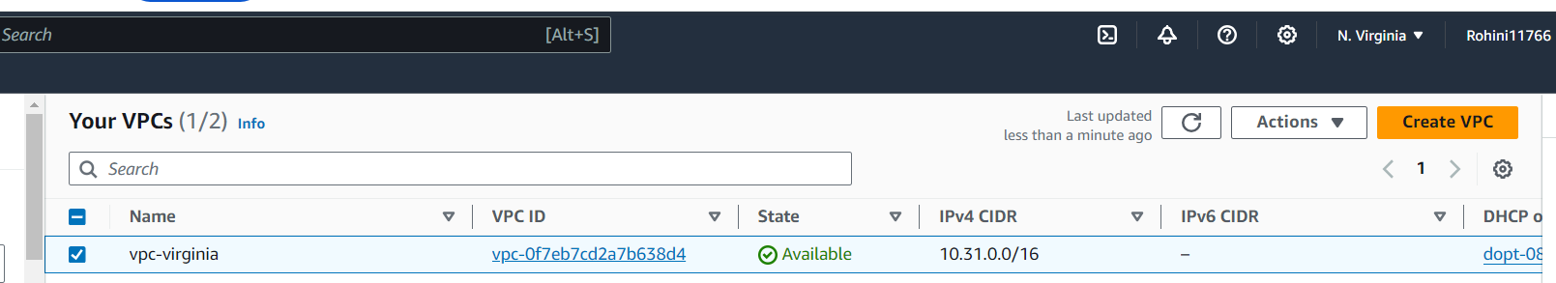

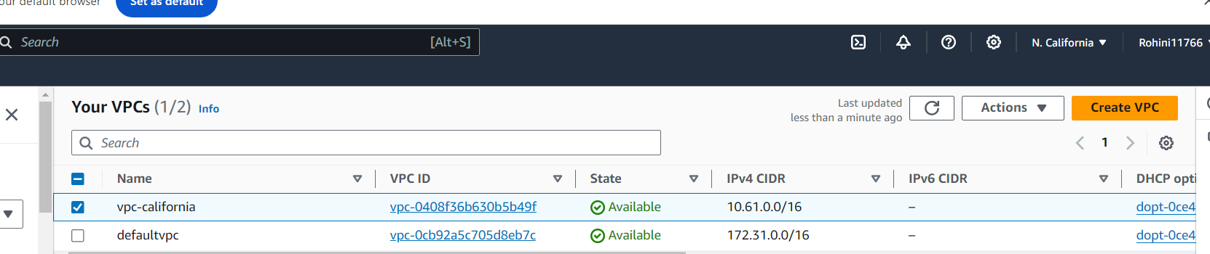

* NOW CREATING THE 3 TRANSIT GATEWAY IN 3 DIFFERENT ZONES

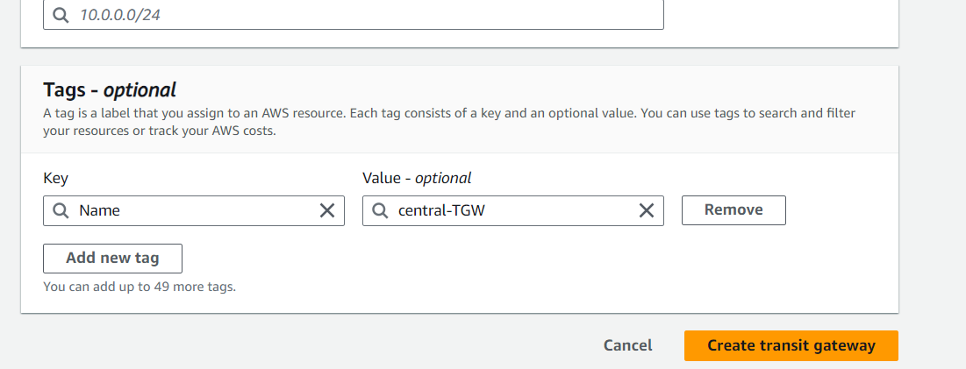

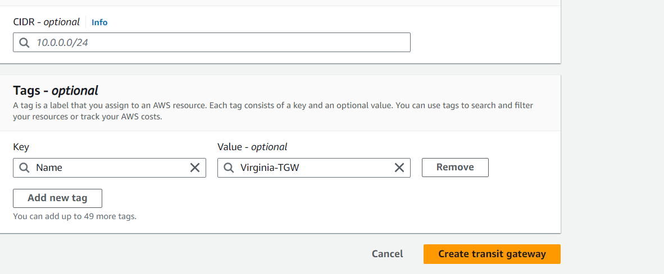

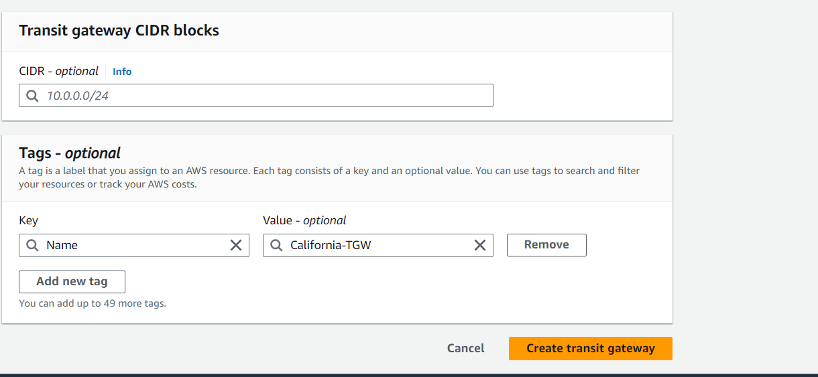

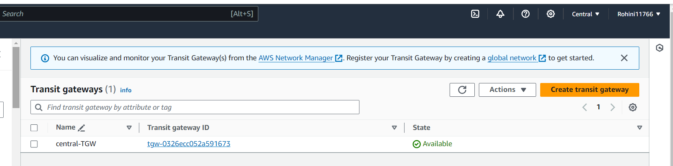

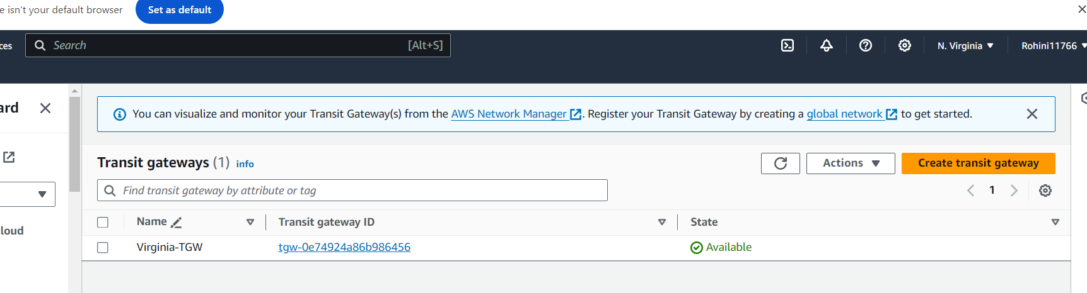

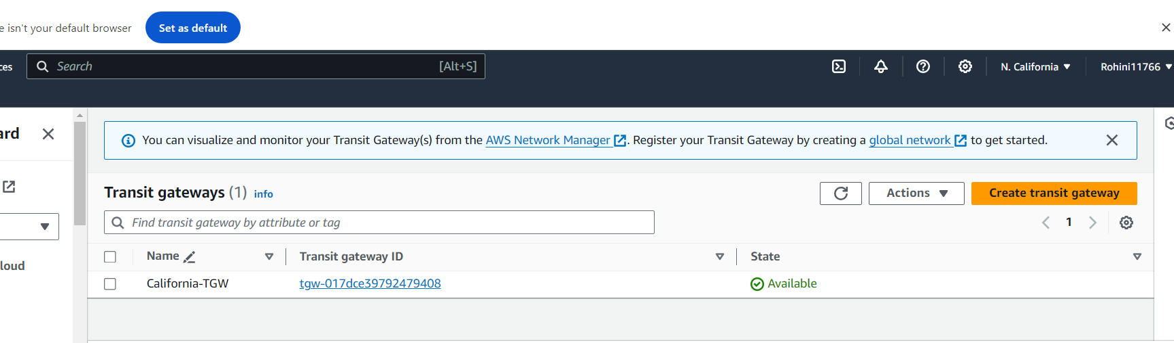

Created the transit gateway

* Now creating the transit attachment in three regions

**CENTRAL**

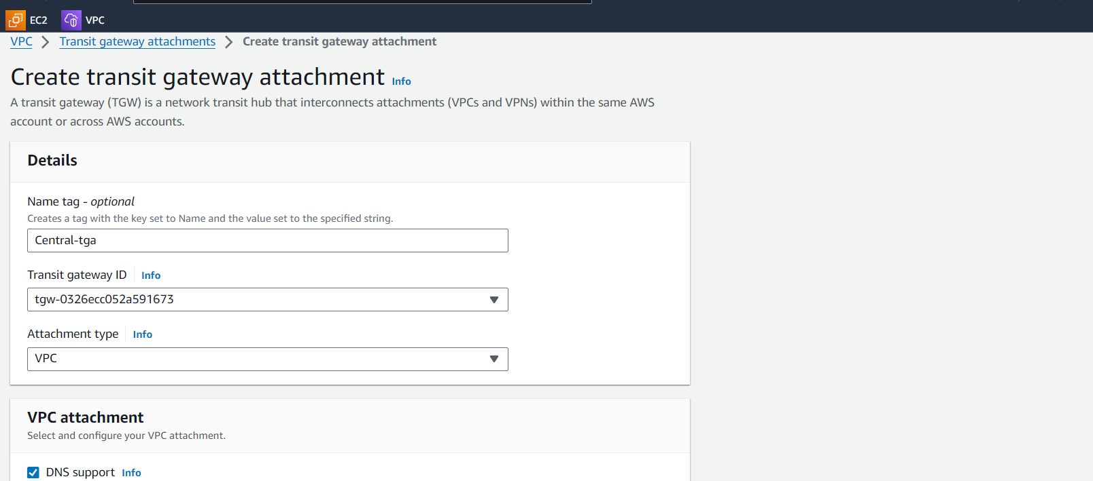

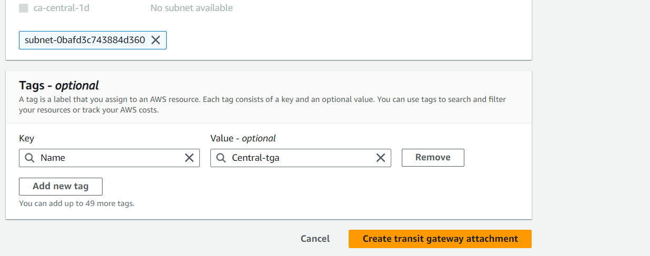

**Virginia**

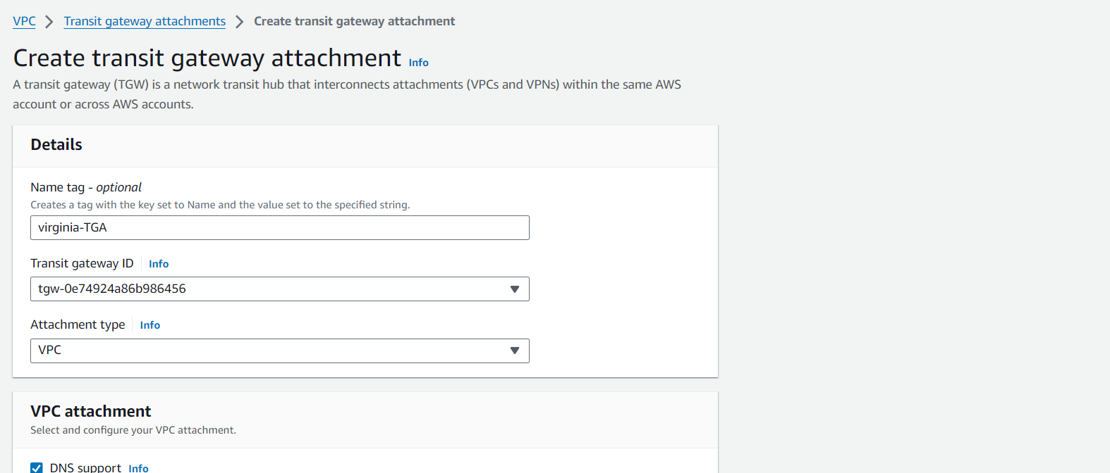

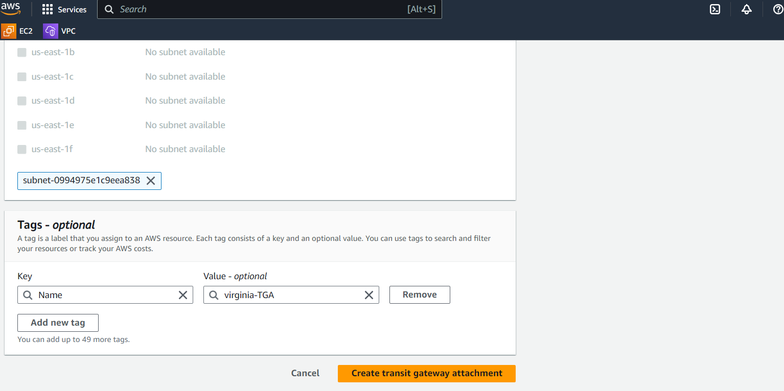

**California**

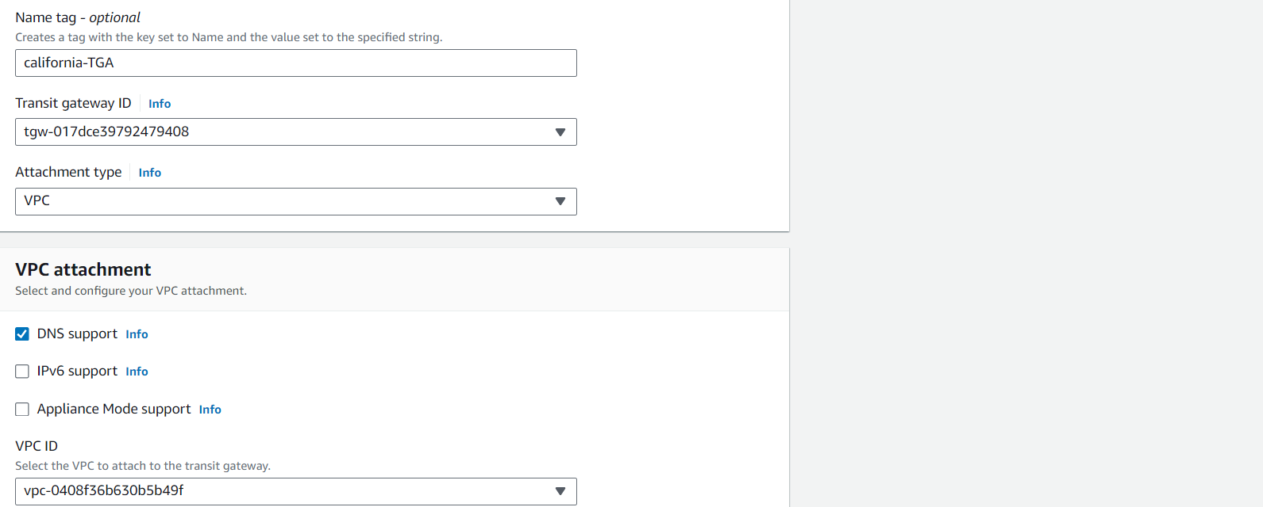

Now gng to route tables of each vpc and connecting the Transit gateway by giving the cidr as the two other vpc one

1. Vpc-central -10.21.0.0/16
2. Vpc – Virginia -10.31.0.0/16
3. Vpc – California -10.61.0.0/16

Changing in the vpc-central

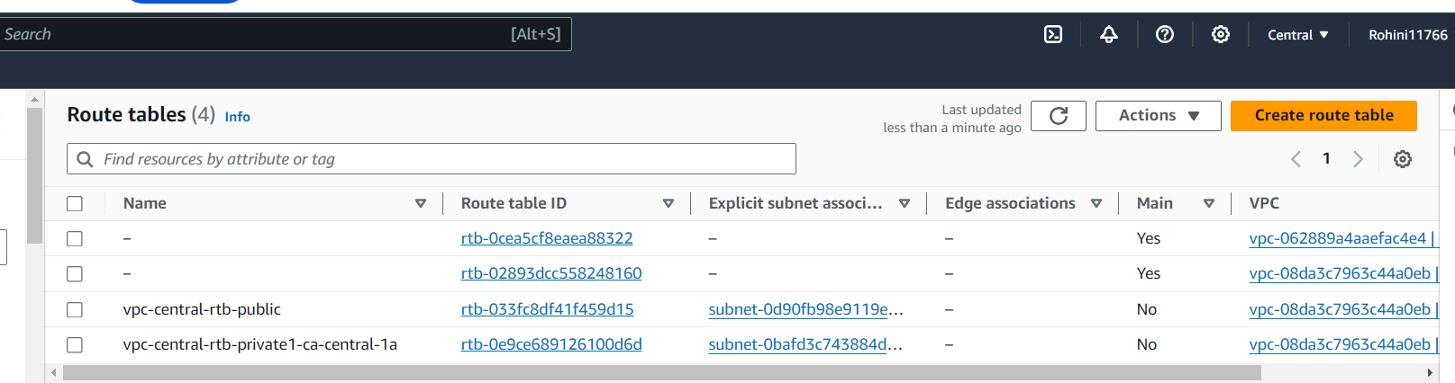

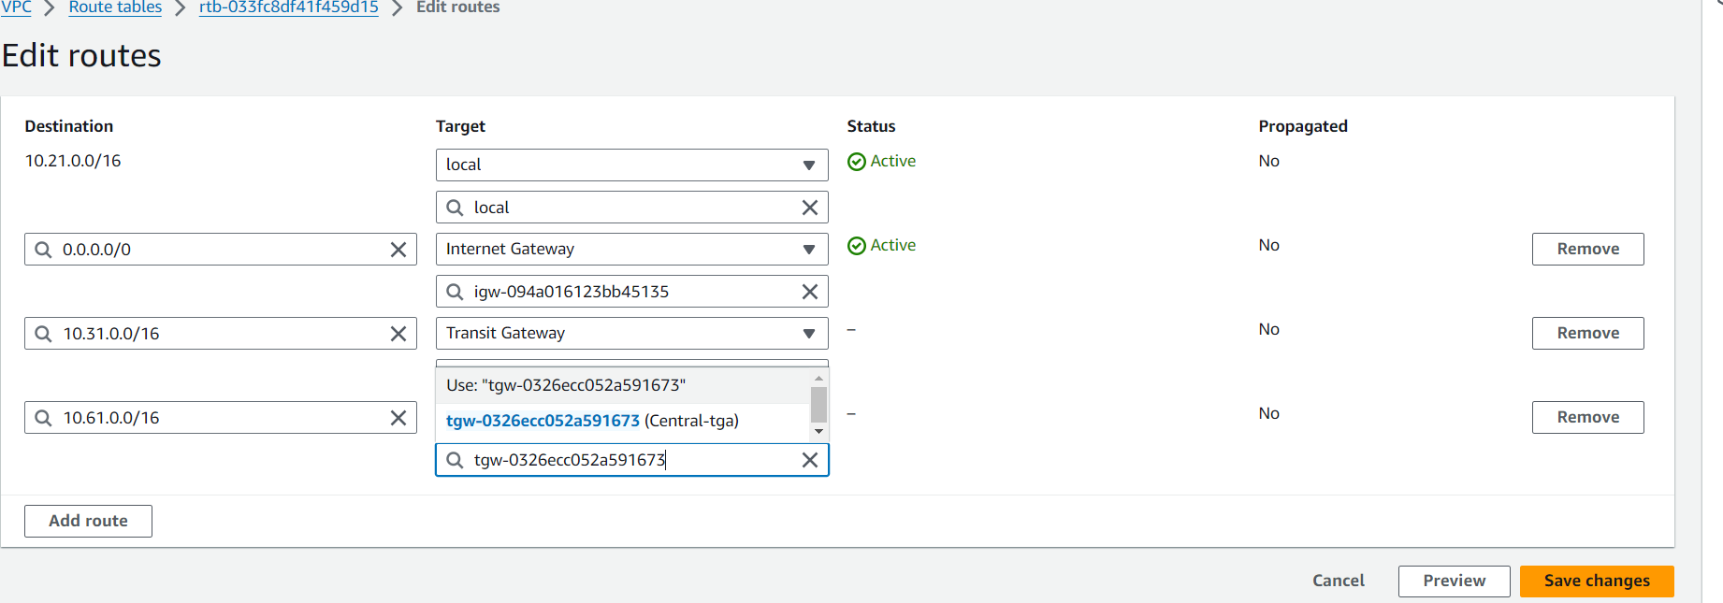

Saving the changes

For vpc – Virginia

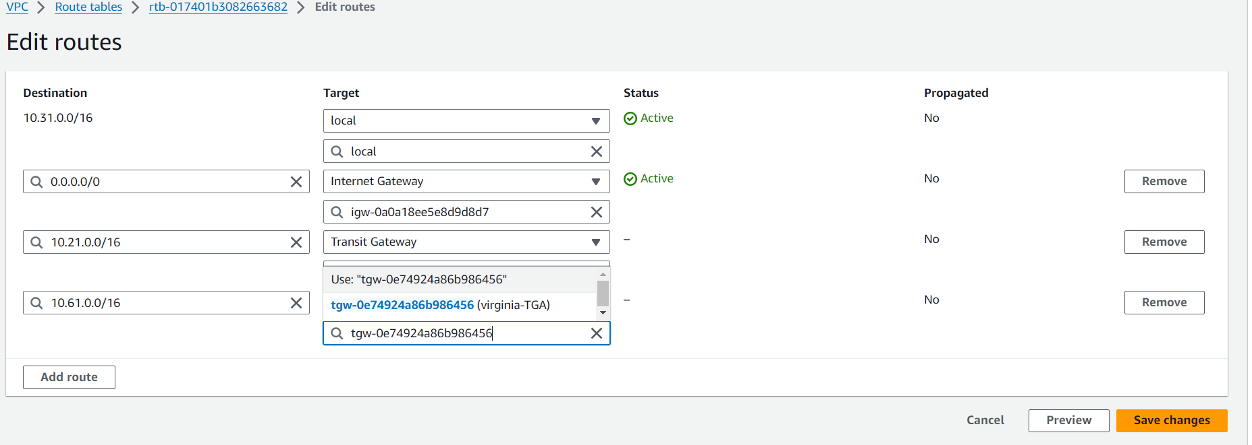

Saving the changes

For California

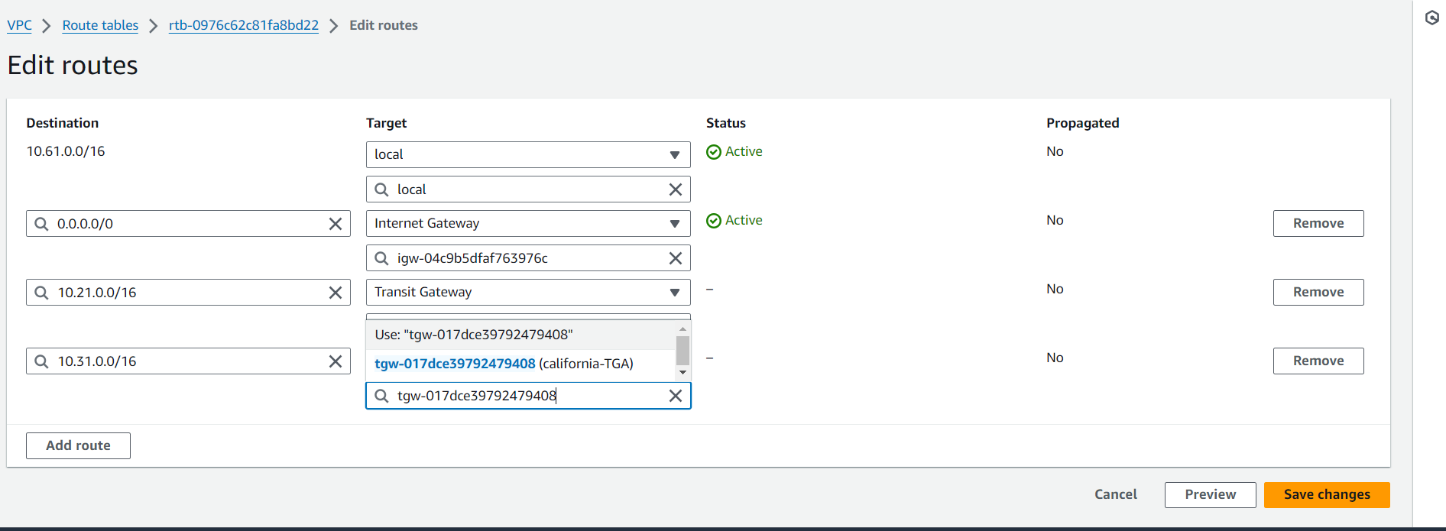

Saving the changes

* Now we need to launch the instances in 3 different regions

Instance-central

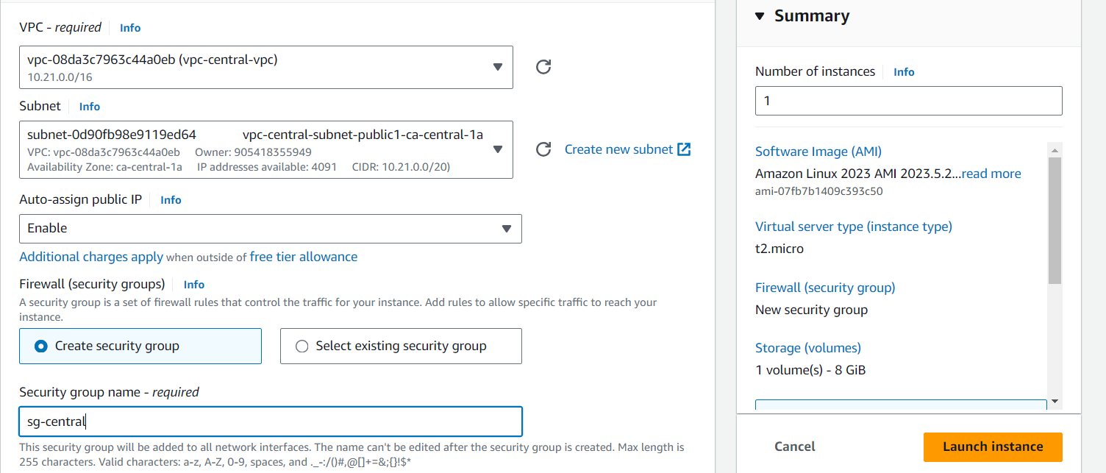

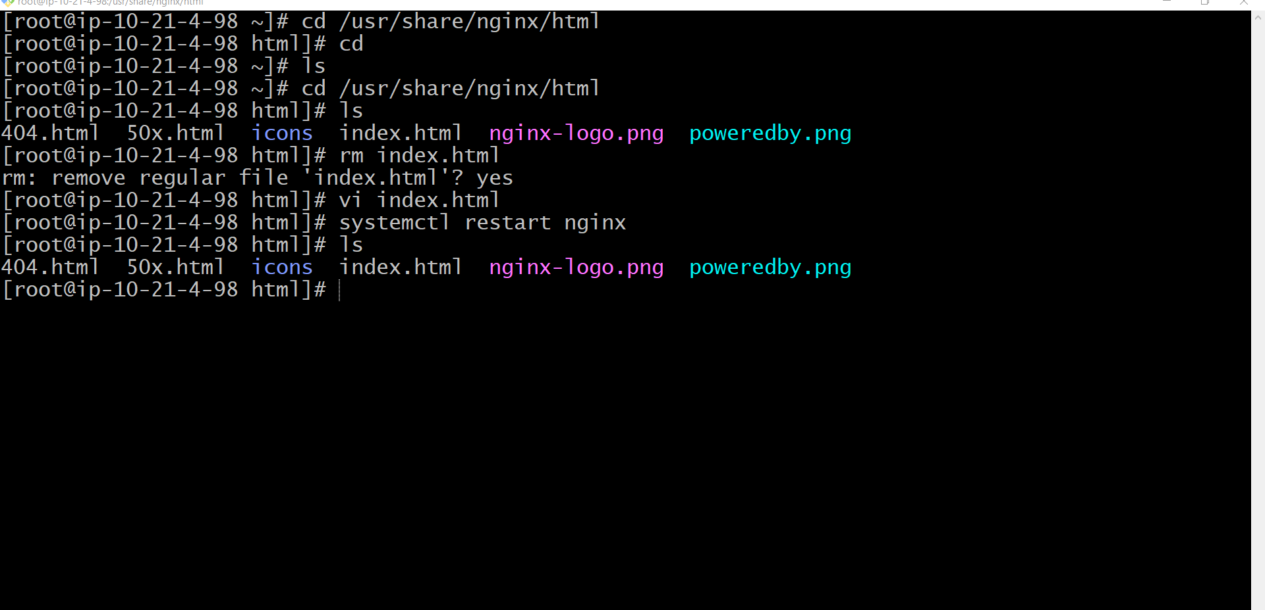

* Connected with private ip

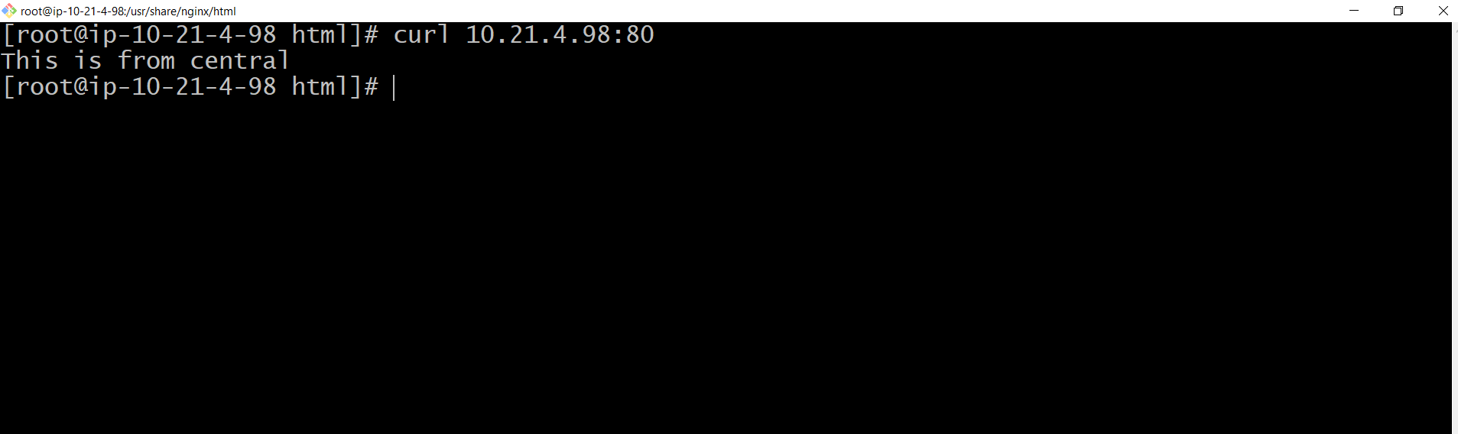

* Instance is created in Virginia

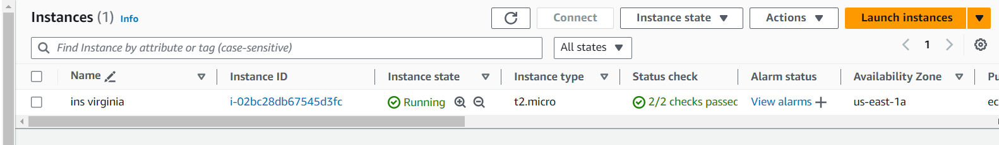

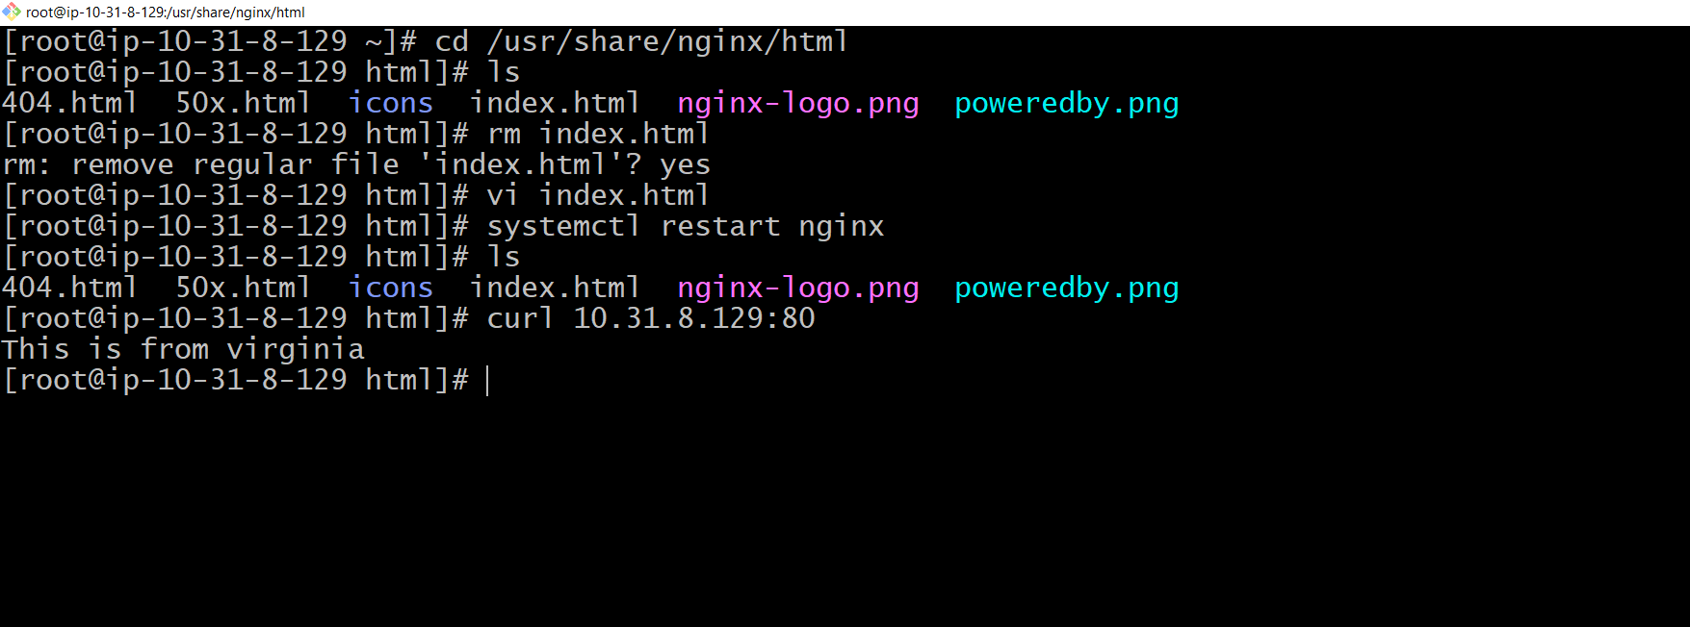

* Instance in California

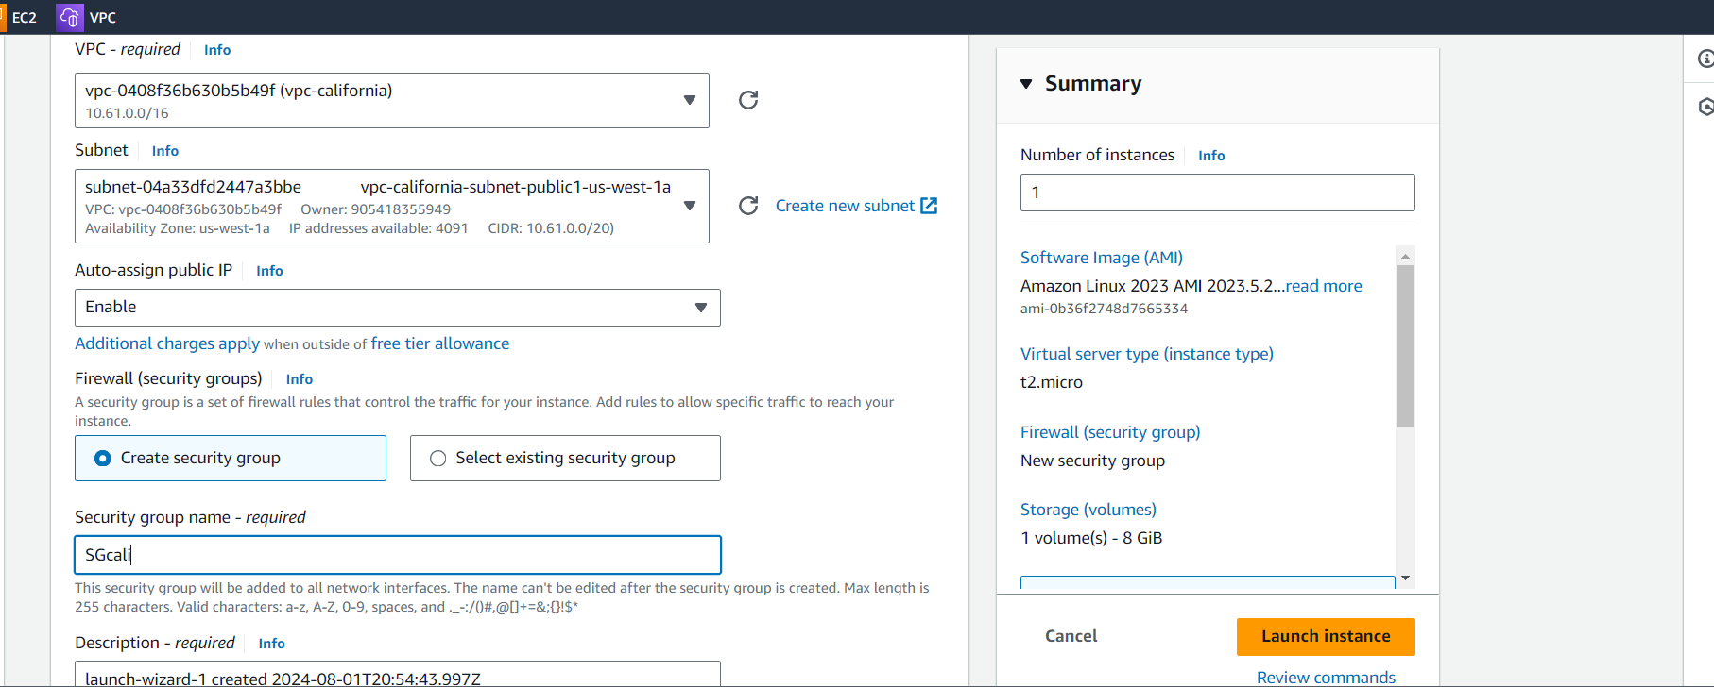

* Launching the instance
* Connected with the instance
* And we are able to connect with the private ip also

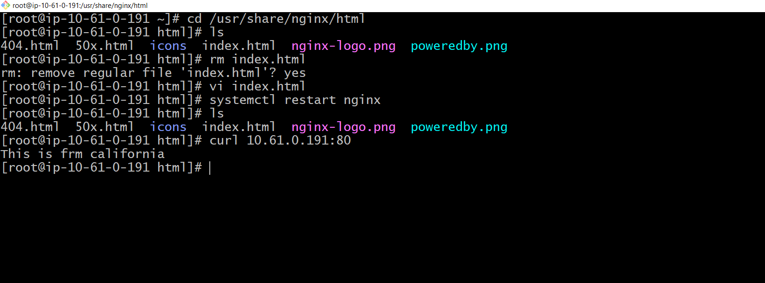







* We are connecting frm one region instance to the different regions instances

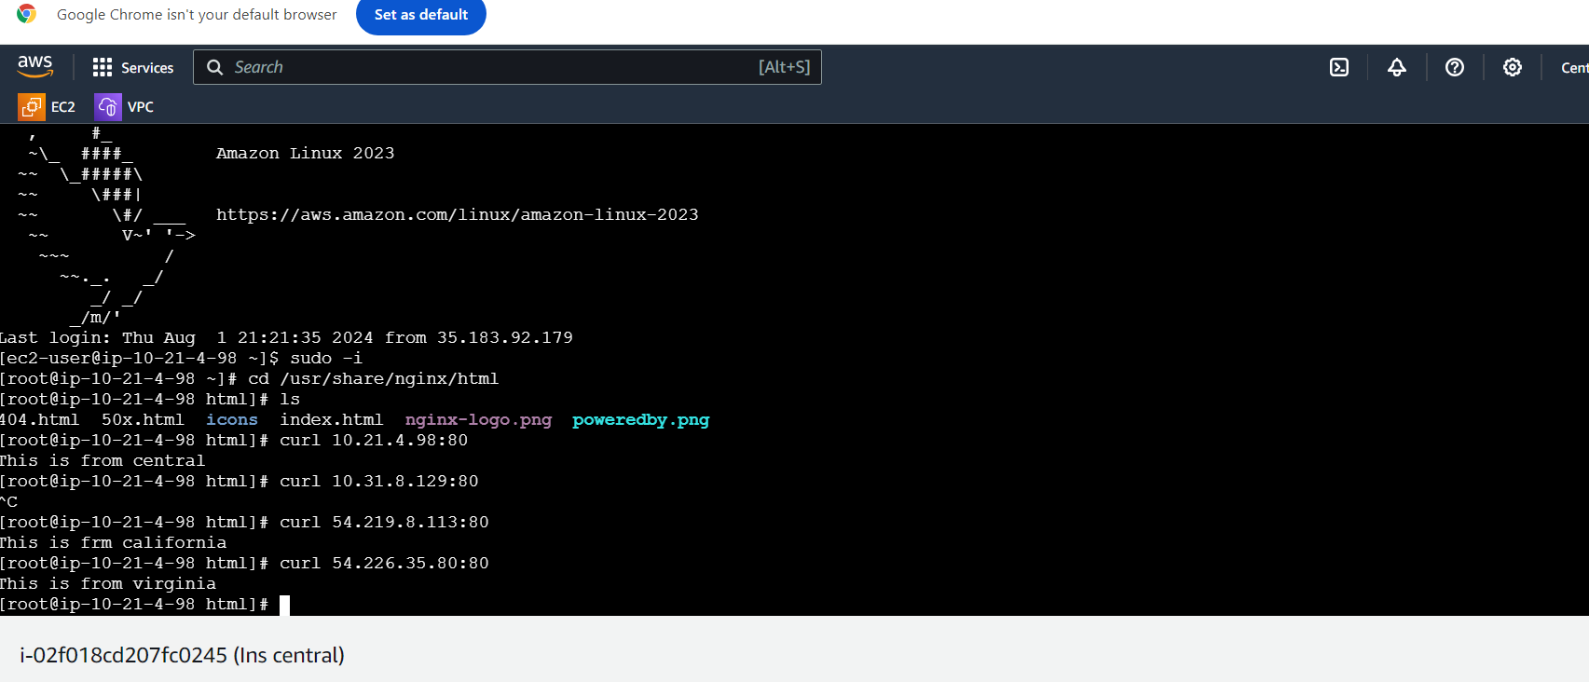

We can see it is reachable. This is how the Transit gateway works...!!!!

* Conclusion:

AWS Transit Gateway simplifies cloud network architectures by acting as a hub to interconnect your VPCs, VPNs, and data centers. It eliminates complex mesh topologies and provides easy scalability, centralized management, and secure network segmentation. As your cloud footprint grows, Transit Gateway is key to maintaining a simple.